**The Beachley Bus (Service No 12)**

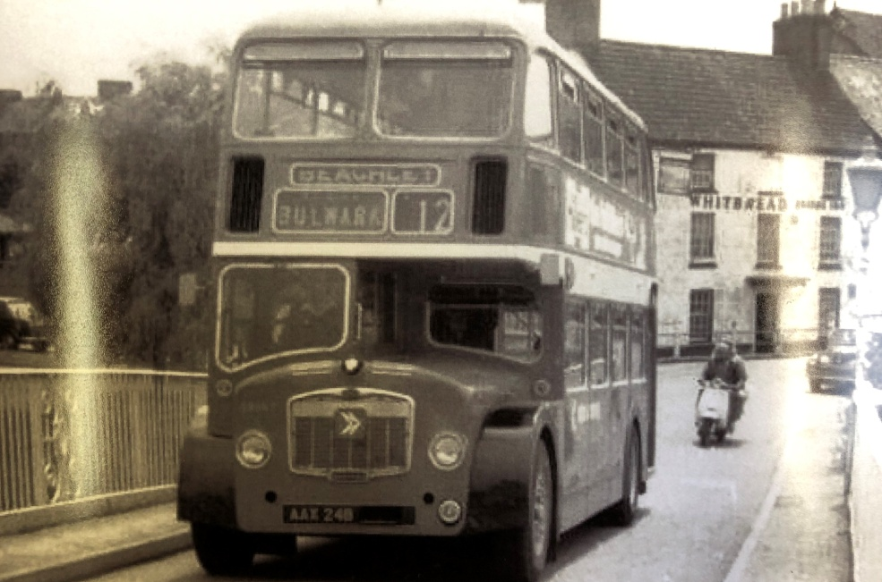

Crossing the Old Wye Bridge with the Bridge Inn in the background

**This bus (AAX 24B) is a Bristol FS6 with ECW coach work, and was operated by National Welsh at the time this photograph was taken (after 1978), and it ran from Bulwark to Beachley via Chepstow town centre and back. However, it’s Fleet No L1063 means that it was the 10th of its type to be delivered to Red & White in 1963, and the ‘L’ denotes ‘Low deck’ so that it can go under the arch in town.**

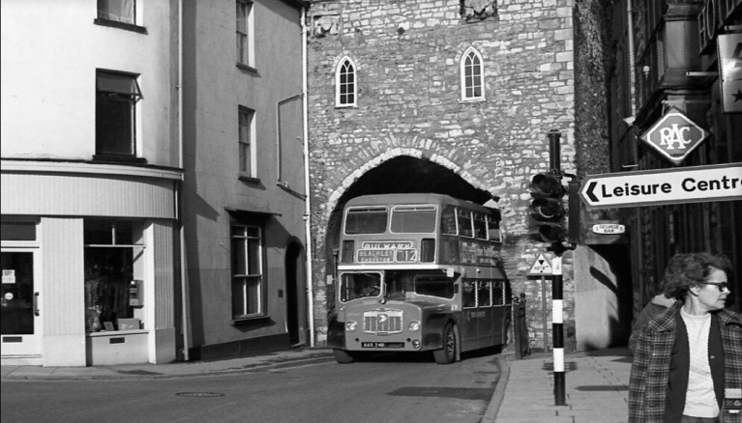

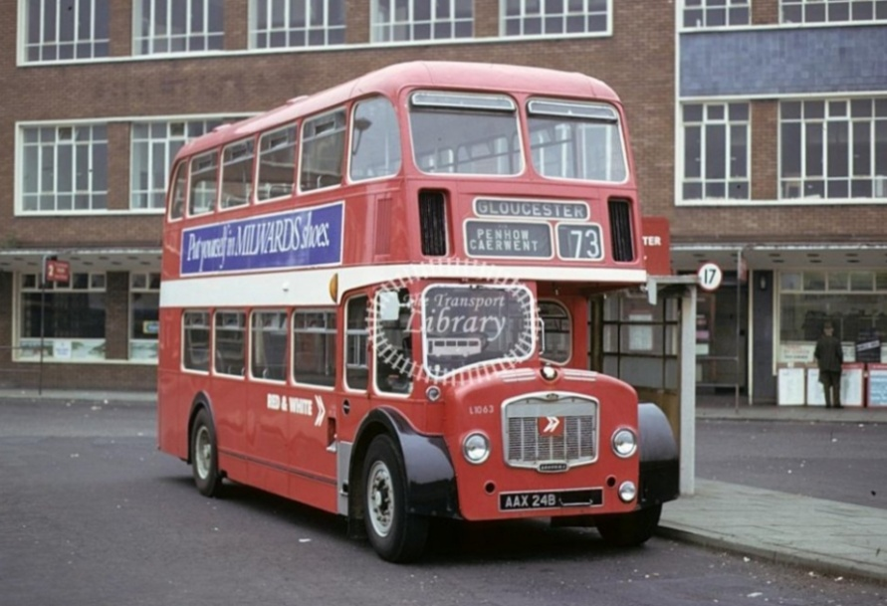

**It then went on to the Newport – Gloucester (73) route, probably because it was able to get under the low bridges on the A48.**

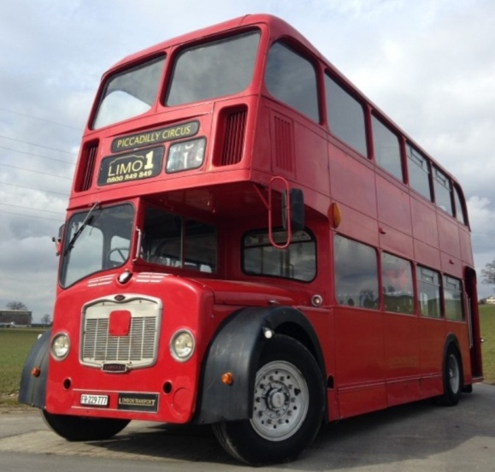

**Here is a picture of L1063 as she looks today, painted in London Transport red, in use as a corporate limousine for hire in Switzerland.**

(Information courtesy of Mark Carey)

