The information contained on this page has been sent in by George Prickett's son, Mike Rees-Prichett. George Prickett, was a boy at BTS in @1924. He went on to serve until the end of WW2 in the Royal Engineers. His memoirs (unpublished) mention some amusing incidents, characters and routines from that time. His Company Commander Capt. Daniels VC and a Mr Mycroft, before whom he was sometimes paraded are not mentioned in the brief history on the web site.

‘We used to rouse at 5.45am. Parade in gym kit & ammunition boots. We then went for a long run as a platoon in column of fours. After the run was a cold wash. Reveille was at 6am. Then march to the church for morning prayers. Parade and march to breakfast, but make one's own way back to the barrack room. Parade in 'fatigue dress' for a march to the workshops. Very good tuition, but every job timed. If one needed to visit the lavatory one asked permission and was allowed about 10 minutes. It was not unknown for an instructor to throw a bucket of water over the partition if one was a little over the allotted time. Galvanised fire buckets and bathtubs had to be emery papered to remove the galvanised protective coat, then burnished so you could see your face in them.’

There is much more like this, with instructors' names and stories of pranks and punishments etc such as the time he was told to 'square up the flowers' in a sergeant's prized garden and cut all the flower petals and leaves square with scissors.

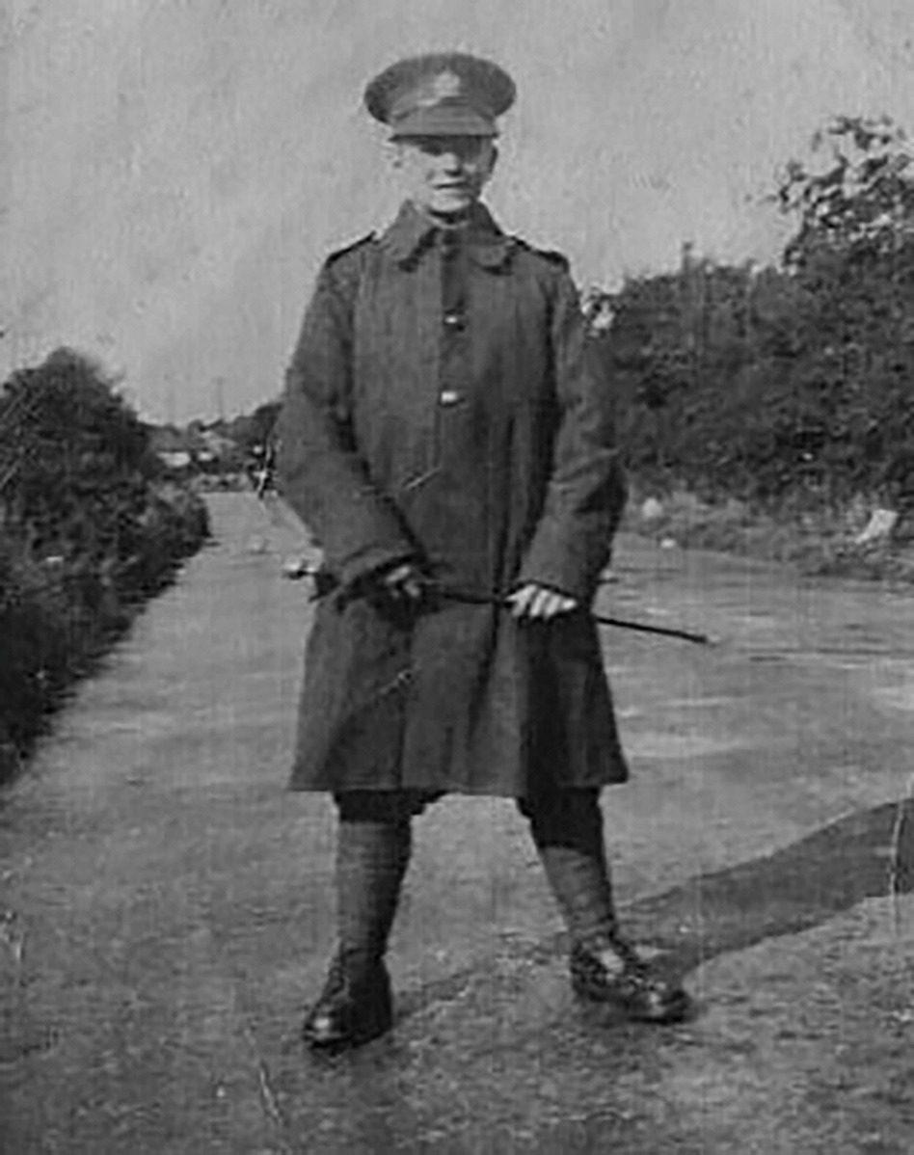
George Prickett aged about 14 at Beachley

